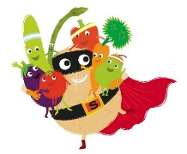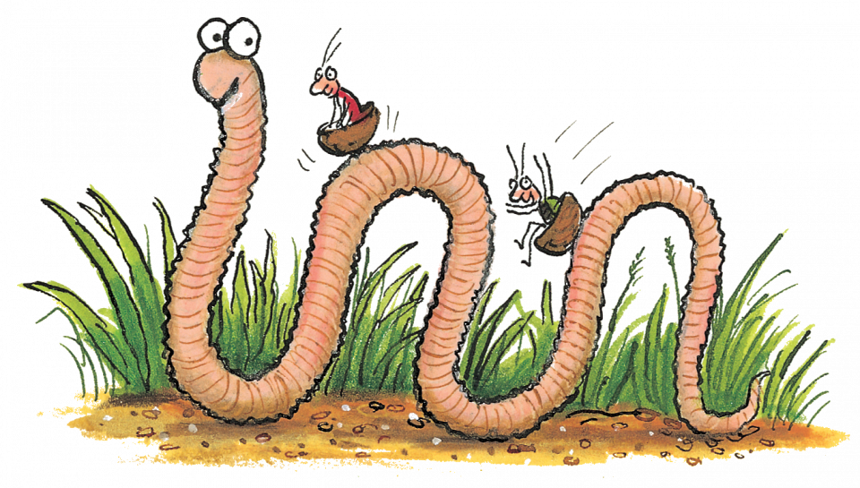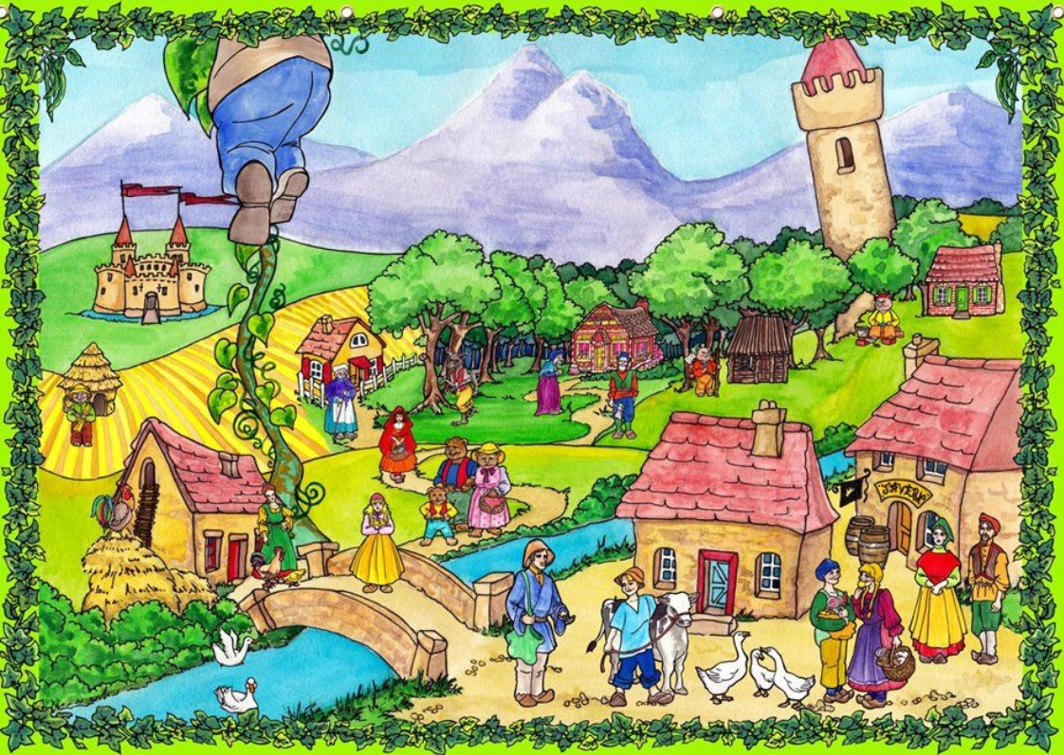

**Summer 1 – Twisted Tales**

Week 1- The Gingerbread Man

Week 2- The Pirates are Coming!

Week 3/4/5- Jack and the Beanstalk, Supertato, Superworm

**Home Learning**

For our Literacy themed topic we would love if you and your child would create a book diary, writing in any bed time stories and new or old books you have read over the Easter holiday (this can be any kind of book, fiction or non-fiction). You can make the diary as exciting and creative as you like, adding pictures of the book and your child reading it, drawings your child has created of scenes from the book, models or crafts you have made with your child of characters or places in the story. Be creative! Please hand in this homework by Friday 27th May

Our next Early Year’s Topic for the first half of the summer term is called ‘Twisted Tales’. The children will be studying Traditional Tales and modern fiction classics like: *The Gingerbread Man*, *Supertato*, *Superworm*, *The Three Little Pigs*, *The Pirates are Coming!* and *Jack and the Beanstalk*.

We will be creating story maps, talking about how stories have a beginning, middle and end, acting out stories and creating our own, designing our own Supertatos, rewriting Superworm as a class with new ideas, using different materials to make a super worm with our own ideas as super powers, talking about authors, and storytelling with puppets. We will also be putting together a pirate dance for International Dance Day to link in with our learning from the book *The Pirates are Coming!*

The teachers and teaching assistants are very excited for this topic as we love telling stories and discussing them at St. Joseph’s as reading is so enjoyable and integral to every child’s development.

We will continue to post Weekend Challenges every Friday, with our Tapestry Superstar winner chosen during celebration time on a Friday afternoon. Please continue to read 5x a week for 10 minutes as normal.

**Twisted Tales**