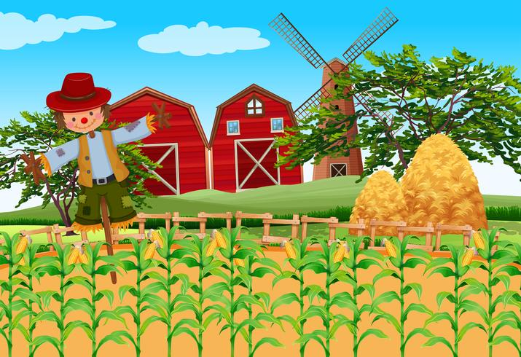

Summer time and the holidays are close at hand. The teachers are very excited for our final reception topic for the year and the sunny days to come. The children will be making scientific observations of animals on the farm as well as minibeasts and insects in the local environment. The Penguins and Puffins children will also be going on their first school trip to the Dorset Heavy Horse Farm (Thursday 14th July 2022, more details to follow soon). We will be linking together our knowledge of Autumn, Winter, and Spring with our new learning on the Summer season to create a complete picture of all four seasons. Healthy eating is on the agenda as we explore (using all 5 senses!) different healthy fruit and veg that is grown on the farm!

To see out the school year we are very excited to invite you to our *‘Summer Fun Songs’* event (Thursday 19th July 2022), which the children have already been practising diligently. Both Reception classes will also be having a Garden Party and have the opportunity to meet their new Year 1 teacher on transition day.

Finally the teachers would like to say a big thank you for all of your hard work this year, especially the brilliant response to our weekend challenges and homework tasks which have been uploaded to Tapestry. Your child will bring home their ‘WOW folder’ after the October half term in Year 1 for you to keep.

**How you can help at home:**

* Continue to read your phonics home reading book 5 times a week for 10 minutes.
* Practising spellings and writing words found in your home reading book either in the front inside page or the back page.
* Writing sentences and words at home about an interest or topic of your child’s own choosing.
* Playing phase 2 or phase 3 phonics games on <https://www.phonicsplay.co.uk/> using the login username: Green2 password: Stjosephs

**Our topic for Summer 2!**

Week 1- World Environment Day, Minibeasts

Week 2- Summer Season & The Queen’s Official Birthday (11th June)

Week 3- Healthy Eating Week, Father’s Day

Week 4- On the Farm

Week 5/6/7- Farm Trip, Transition, Summer Fun Songs, Garden Party

**My favourite memory:**

With the help of your parent/carer, write down your favourite memory of your time in Reception on the sparkly paper provided.

**Due Friday 1st July 2022**

**Home learning**

**Topic Task**

**Down on the Farm!**